Assignment 7

- Count all orders for October 3
→ Find how many orders were placed on the date October 3.
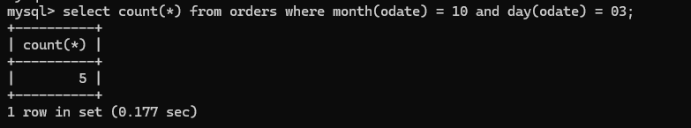
- Count the number of different non-NULL city values in the Customers table
→ Determine how many unique cities (ignoring blank or missing entries) are listed for customers.
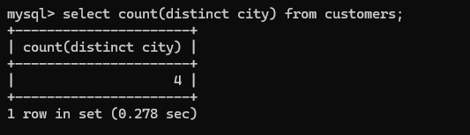
- Select each customer’s smallest order
→ For every customer, identify the order with the lowest value.
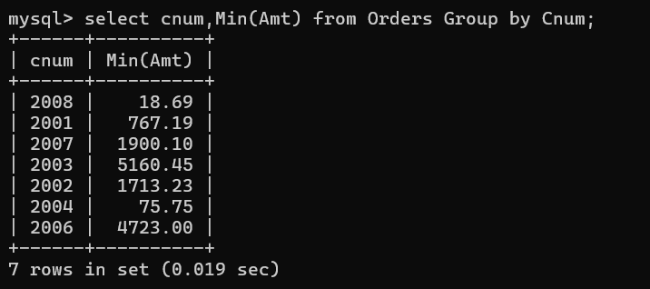
- Select the first customer, in alphabetical order, whose name begins with G
→ From the list of customers, find the one whose name starts with the letter “G” and comes first alphabetically.
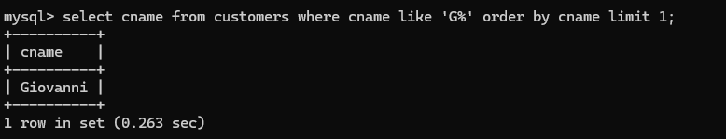
- Select the highest rating in each city
→ For every city, show the maximum rating recorded.
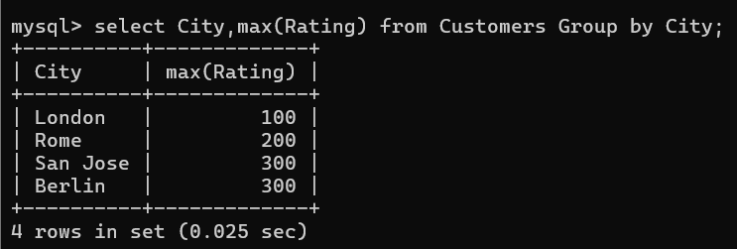
- Count the number of salespeople registering orders for each day (counting each salesperson only once per day)
→ For every day, calculate how many distinct salespeople placed at least one order, even if they placed multiple orders that day.
